**Q. Write a Problem Analysis Chart (PAC), Algorithm and Flowchart to convert the Distance in Miles to Kilometres.**

PAC

|  |  |  |  |
| --- | --- | --- | --- |
| **Data** | **Processing** | **Output** | **Solution Alternatives** |
| Distance in Miles | Kilometres = Miles*1.609 | Distance in Kilometres |  |

Algorithm

* Start
* Use variable **Miles**, **Kilometres**
* Read **Miles**
* Calculate **Kilometres** = **Miles** * 1.609
* Print **Kilometres**
* Stop

Flowchart

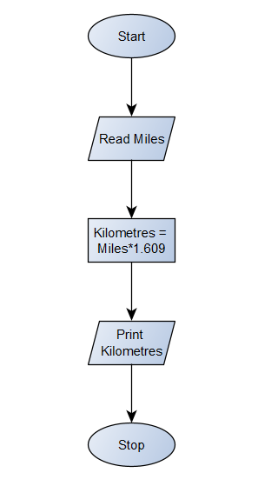

Python Program

Miles = float(input(**"Enter the distance in miles : "**))  
Kilometres = Miles*1.609  
print(**"Distance in kilometres :"**, Kilometres)